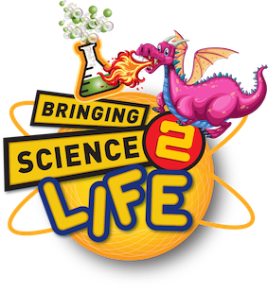  A Science2Life Science iT! Activity  Check out our Energy Ball and Creative Circuits kits – amazing items which help bring the topic of electricity 2 life! | 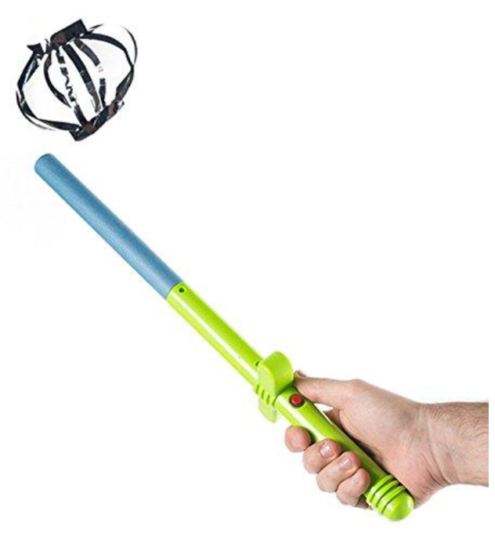  CONTENTS  - Wandarama  - Book of mylar foils  - Foil dish  - Small bag of packing peanuts  - Teaching notes.

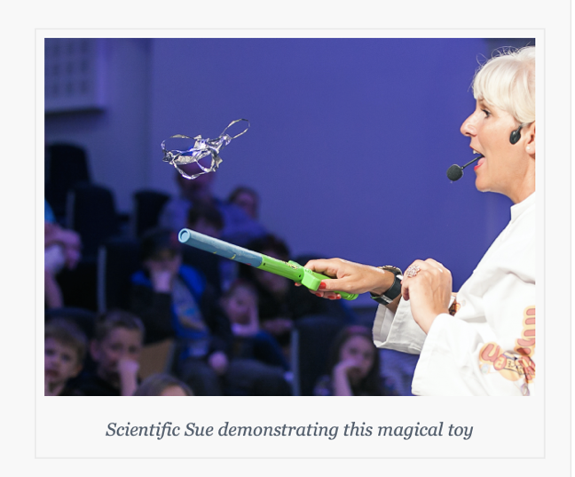
This ingenious toy is a version of a Van de Graaff machine. Charge it up and watch your tinsel shapes fly!

Science2Life’s Science iT! Activities take everyday life objects, toys and knick-knacks and turns them into fun, innovative science projects.

As you are learning how to float the mylar shapes, remember that you don’t have to constantly press the button. Just press the button for a few second to build up a static charge. Pressing the button continuously both drains the batteries and lessens the effectiveness of the Wandarama stick.

How does this magical toy work?

Housed in the handle of the Wandarama stick are 2 plastic rollers and an elastic band – a miniature mechanism similar in design to Van de Graaff’s invention. A Van de Graaff generator consists of a hollow aluminium sphere seated on top of an insulated column that houses a rubber belt moving at high speeds

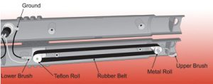

The belt draws charges from the roller in the base of the device and deposits it ultimately on the outside of the aluminium sphere.

Depending on the materials the rollers and belt are made from the sphere can be positively or negatively charged. The Wandarama’s design works in a similar way.

This amazing toy makes it possible for you to understand how static charges form, interact with other charged and uncharged objects, and grasp the concept of static electricity and electric force fields in a fun and engaging way.

What can this Wandarama do?

1 Apply ‘invisible glue’ to paper!
Place a piece of paper (A4) against a wall – it will fall immediately. Hold the paper up against the wall again, but this time charge up your Wandarama stick and use the long length it to press the paper to the wall.
Why is the paper held in place by rubbing the wand over the page?
The Wandarama makes the paper become positively charged. This positive charge attracts electrons in the neural wall to the surface and maintains the attraction (unlike charges attract) until the papers loses it charge to the air – the speed at which this happens depends on humidity levels.

2 Attract a water stream
Hold the charged wand near a thin stream of water – the water stream will bend towards the Wandarama. The positively-charged wand interacts with the polarised water molecules causing the negative side of the hydrogen-oxygen dipole to rotate and attract to the stick, bending the water towards the wand.

3 Make the mylar shapes come to life!
Charge the wand and allow one of the mylar shapes to be charged by touching it to the wand – let is fall to the stick. The mylar shape will be immediately repelled from the stick due to the repulsion forces between like charges.

If your hand is held near the wand, the mylar will be attracted to your hand because you are neutral. Once the mylar touches your hand, it will instantly become grounded, losing its positive charge. With the positively-charged wand held in close proximity, the mylar will again be attracted to the wand (induction) and will then leave your hand and fly towards the wand – this action is repeated and you will be able to get the mylar to bounce backwards and forwards between your hand the stick.
4 Make ‘packing peanuts’ dance!
Out of paper make a tube which can be pushed onto the wand snuggly. Glue the foil tray to the tube and add some of the packing peanuts to it. Holding the wand in front of you press the button and charge it up. The packing peanuts will fly out of the dish.
5 Make flying saucers
Stack small foil dishes in the larger foil dish. Press the charging button and watch the foil dishes fly off one at a time.
If it is a humid day the charged water molecules will steal the charges from your Wandarama stick – to avoid disappointing your audience and yourself (!) dry your wand carefully using a hair dryer

Science2Life’s Science iT! activities and programmes
Children love to be engaged in learning, especially through interactive projects that they can really get involved and be hands on with.
Science2Life’s Science iT! activities and programmes are part of our STEAM Academy. The activities use everyday life objects, toys and knick-knacks and turns them into fun, innovative, hands-on experiences designed to encourage children to:
- discover the amazing world of science and engineering
- to perform engaging activities that show how science and engineering is at work in their everyday lives
- to foster a lifelong love of science and engineering

- to give a basic grounding in scientific concepts and scientific thinking
- to increase children’s motivation to learn and
- enhance their perception, creativity and logic.

Hands-on learning is learning by doing.

Children involved in our ‘Science iT!’ activities and programmes are introduced to various STEAM learning methods and activities. Our creative programmes involve learning activities that require active thinking and experimenting to find out how things work. We all know how curious children are about the world around them and how they love using the word ‘why?’
The aim of our activities is to provide optimal learning opportunities that strategically help children grasp mathematics, engineering and science concepts.
With the inclusion of the arts component into STEM it makes it more fun to learn, and more approachable to children.
Art education allows children to learn things in a more open-ended way and make them applicable to real life.
Links to the curriculum
All of Science2Life activities can be used to entertain children – however they have been created with the curriculum in mind, so are perfect activities to generate mesmerizing examples of the topics they can be used to explore.
Our Science iT! activities can up scaled-up to be used in workshops within the classroom, for festival and birthday celebrations, which provide opportunities for children to collaborate on initiatives, explorations and creations.
The idea behind our Science iT! activities is to ignite children’s natural innate curiosity about the world around them (and the items in it) and to channel their enthusiasm for scientific discovery as early as possible.
Currently Science2Life have the following Science iT! activities:
- The Magical EVANESCO Spell
- The Magical AMORTENTIA Spell
- The Super Bouncing Bubble Kit
- Make your own Fossil Kit
- Colour Changing Bracelet Kit
- Pneumatic Monsters Activity
- Creative Circuits
- The Magical Wandarama
- Gone Fishing
- The Jitter Bug
Each of the above activities can be turned into a workshop programme! Interested? Give us a call!

